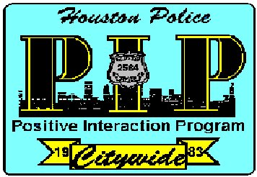
Chief's Citywide
"Positive Interaction Program"

For the month of September our program presentation topic will be the:

HPD SWAT TEAM

Special Weapons and Tactics
A special Citywide PIP presentation will outline a brief history of why SWAT teams were created nationwide, the early days of the Houston SWAT detail, what scenes SWAT responds to, how SWAT officers are selected to the team, and describes our current team’s yearly training regimen. SWAT vehicle and equipment will also be on display.
The meeting will also be streamed live with sign language interpretation
on HPD’s YouTube channel:
youtube.com/houstonpolice
Closed captioning can be enabled on the YouTube video,
or found at:
streamtext.net/player?event=CitywidePIP

Tuesday, September 10th 2024 7:00 p.m.
1602 State St. Houston, Tx 77007

From: Officer James Sobota
Hope to see you there.
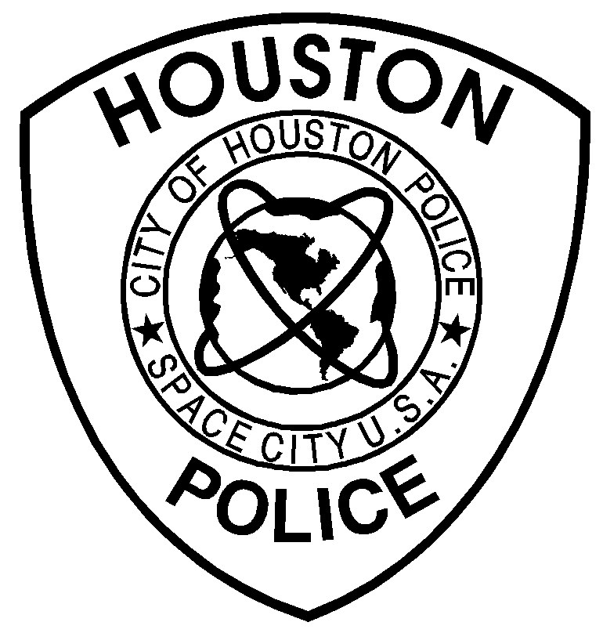

Voice # 713-308-9079
E-mail: james.sobota@houstonpolice.org

American Sign Language (ASL) Interpreter

and Captioning provided

