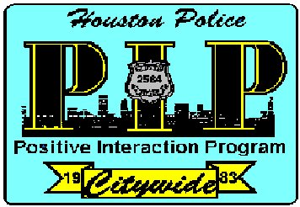
Chief's Citywide
"Positive Interaction Program"
Holiday Networking Meeting

For the month of November our program presentation topic will be the:

HPD Cyber and Financial Crimes Division

Protecting Your Money

The HPD Cyber and Financial Crimes Division

will outline common telephonic, text, and internet scams used by criminals to separate you from your money. We will review some older tried-and-true scams used and discuss the new twists the scammers are recently using to improve their game with technology and ways to avoid these scams and what to do if you become a victim.

The meeting will also be streamed live with sign language interpretation
on HPD’s YouTube channel:
youtube.com/houstonpolice
Closed captioning can be enabled on the YouTube video,
or found at:
streamtext.net/player?event=CitywidePIP

Tuesday, November 12th 2024 7:00 p.m.
1602 State St. Houston, Tx 77007

From: Officer James Sobota
Hope to see you there.
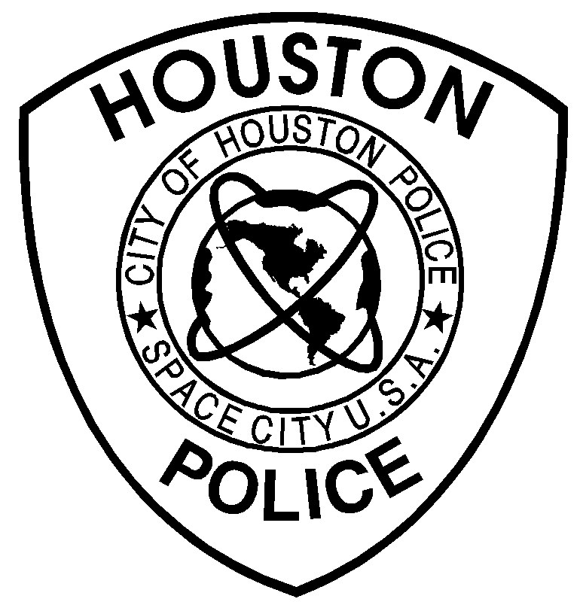

Voice # 713-308-9079
E-mail: james.sobota@houstonpolice.org

American Sign Language (ASL) Interpreter

and Captioning provided

